Chapter 4. NSGA-II

NSGA-IIs are popular approaches to generating Pareto optimal solutions to a multi-objective optimization problem. With the non-dominated sorting scheme, NSGA-II can balance different objectives as much as possible. In MCBA, it using overlapping area of circles to ﬁnd out some candidate locations which can deploy charging stations then record them to a set. To employ a NSGA-II for finding a solution for the charging station deployment problem, we encode all candidate locations of charging stations into a set of genes, which is known as a chromosome or an individual. In our scheme, there are four primary phases – initialization phase, crossover phase, mutation phase, selection phase. Individuals are created randomly in the initialization phase. In the crossover phase, genes are copied and are delivered to offspring. In the mutation phase, genes change their information content. Through the phases of crossover and mutation, different chromosomes are generated for maintaining the diversity of the next generation of solutions. In the selection phase, non-dominated sorting scheme is used to a preserve the diversity of different objectives. After many generations, the strongest genes are obtained. The chromosomes are updated continually in the main loop until the stopping criterion is met. The process of the proposed NSGA-II approach is displayed in Figure 3.

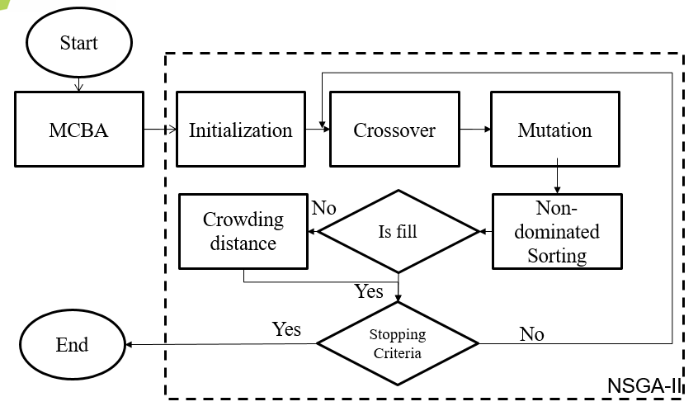Figure 3. Flowchart of the proposed NSGA-II

* 1. Representation and Initialization

In the proposed approach, we assume that each sensor node can be covered by multiple charging stations and receives power from multiple charging stations simultaneously. The WRSN deployment space is regarded as a cuboid that its length is *L*, width is *W* and height is *H* respectively. In order to efficiently avoid the interference from obstacles, we need to consider the actual situation thus achieve optimal coverage. So we placed the charging station in where is equal to *H* height as well as the sensor nodes are random distribute floor in space. One the basis of these assumptions, a point $s_{n}$ with three coordinates ($x_{n}, y_{n}, z_{n}=0$) represents a sensor node and $c_{m}$ with three coordinates ($x_{m}, y_{m}, z_{m}=H$) represents a charging station in three-dimensional space. According to the MCBA algorithm, we can get a candidate point set $V$ which represent all the places where the charging station may be placed. Each candidate point is considered as a genetic cell.

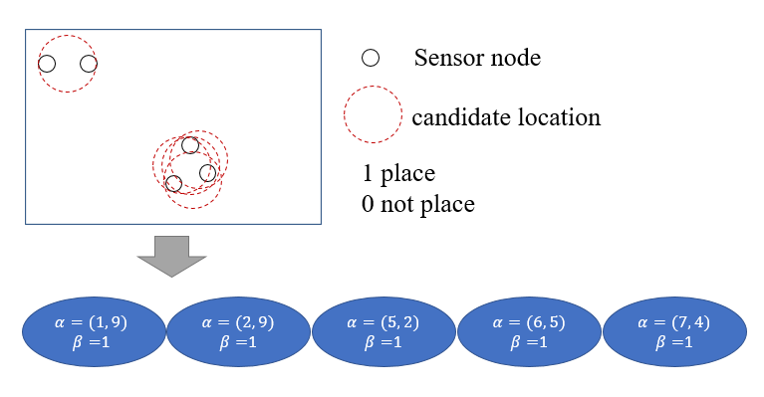A gene which is a component of a chromosome, has two indicators, $α$ and $β$ that store the candidate position of charging station and the point is placed or not placed. 0 is placed and 1 is not placed. Figure 4 presents the process of transforming a candidate set into a chromosome. The coding example for a WRSN including five sensor nodes.

Figure 4. Example of a chromosome coding

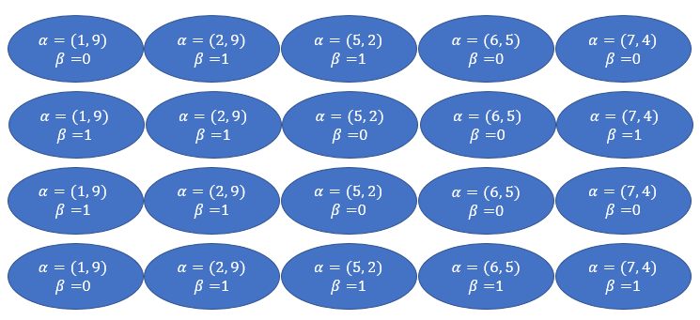In the initialization phase, $N_{i}$ individuals are created randomly. For example, in Figure 5, we randomly generate four chromosomes.

Figure 5. Example of a initialization

* 1. Crossover

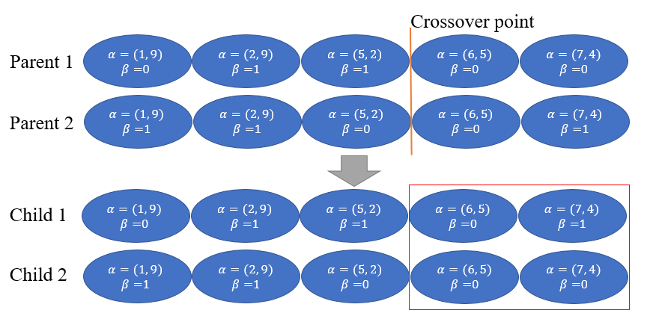In the crossover phase, switching point is randomly selected. At each iteration, parents selected after replication are exchanged for genetic, so that the new offspring can retain some of the characteristics of the parents. In this study, single-point mating was used. The process is determined by the crossover rate $r_{c}$, which is a floating number between zero and one. If the generated random number is less then $r_{c}$, the steps were to randomly select two replicating parents, and randomly generate a random number on their chromosome as a crossover point, and exchange the genetic after the crossover point. As a example of the crossover is presented in Figure 6.

Figure 6. Example of a crossover

* 1. Mutation

The purpose of mutation is to generate the genetic that have not appeared in the parents, in order to prevent the best solution from falling into the local optimal. In this study, single-point mutation was used to randomly select a chromosome to generate a random mutation point and randomly change its genetic. Similar to the crossover phase, the mutation phase is determined by the mutation rate $r_{m}$, which is a floating number between zero and one. If the generated random number is less then $r_{m}$, then one gene of the chromosome is randomly selected for mutation. In this case, if the selected point is 0, it will become 1. The opposite if the selected point is 1, it will become 0. An 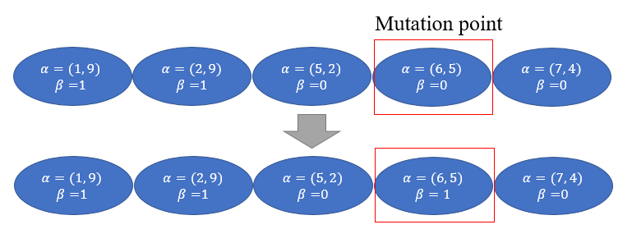example of the mutation is presented in Figure 7.

Figure 7. Example of a mutation

* 1. Selection

In the selection phase, all chromosomes are decoded to obtain their information, such as the number of charging stations, the sum of the received energy and total coverage of charging stations. These parameters were employed to calculate the fitness value.

To know the number of charging stations for each chromosome, the minimize *M* is given by

|  |  |  |
| --- | --- | --- |
|  | $$minimize M= \sum_{i=1}^{l}{β},$$ | (3) |

where $l$ is the number of genes in chromosome.

The total coverage of charging stations $C_{rate}$ is used to know the charging stations’ cover rate. It’s expressed as

|  |  |  |
| --- | --- | --- |
|  | $$maximum C_{rate}= \frac{\sum_{i=1}^{n}{c_{i}}}{n},$$ | (4) |

where $C_{i}$ is the sensor node $i$ which is be covered by charging station.

We can use the Friis transmission equation to get the energy received by each sensor node. The sum of the received energy is

|  |  |  |
| --- | --- | --- |
|  | $$maximum P= \sum_{i=1}^{n}{p_{n}},$$ | (5) |

where $p_{n}$ is each sensor nodes of receives power from multiple charging stations. We can obtain it value through Eq. (2).

From the initial population $N_{i}$ and the population $Q_{i}$ after the crossover and mutation phase, it becomes a $2n$ population. In order to retain the first 50% of the population into the next generation, we must calculate the non-dominated sorting and the crowding distance. According to the ranking from high to low. If they encounter the same level, they will be ranked according to the crowding distance.

* + 1. Non-dominated sorting

The main purpose of non-dominated solution ordering is to divide the initial population $N_{i}$ into several groups of non-dominated solution sets according to the objective function value of each chromosome. Calculate the number of chromosomes dominated by other chromosomes. If the number of chromosomes is dominated by 0, which means that the chromosome is not dominated by other chromosomes, they are defined as level 1 and removed from the population. Then calculate the number of chromosomes dominated by other chromosomes from the remaining population. If the number of chromosomes dominated is 0, they are defined as level 2. Screen the populations in this way and increase the rank values in sequence until the entire population is sorted. A pseudcode for non-dominated sorting is present in Algorithm 1.

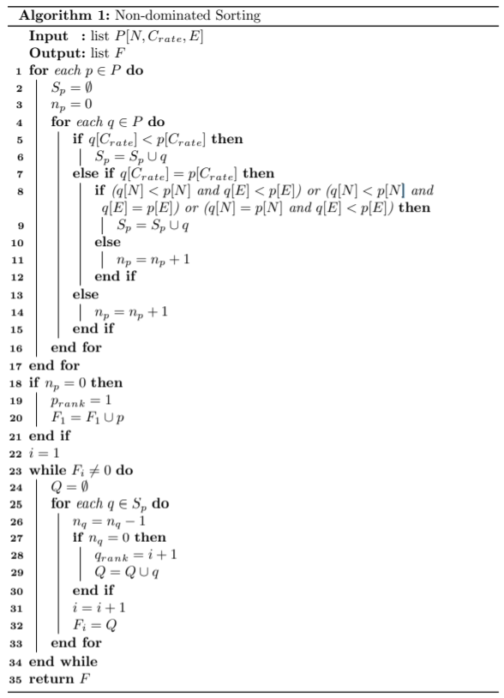*P* is the set of population, *N* is the set of the number of charging station for each chromosome, $C_{rate}$ is the set of the total coverage of charging stations for each chromosome, *E* is the set of the sum of the received energy for each chromosome.

* + 1. Crowding distance

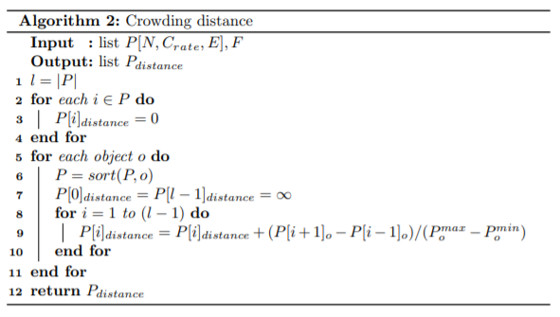According to the ranks sorted in the previous step, the chromosomes of the same rank are taken out and the crowding distance is calculated. The concept of crowding distance is the denseness between the chromosome and its surrounding chromosomes. When the crowding distance is smaller, it means that the chromosome falls in a relatively crowded range. If the crowding distance is larger, it means that the chromosome falls in a relatively loose range. The formula for the crowding distance is as follows:

|  |  |  |
| --- | --- | --- |
|  | $${CD}_{i}=\sum_{o=1}^{O}{\frac{f_{o}(x_{i+1})-f_{o}(x_{i-1})}{f_{o}^{max}(x)-f_{o}^{min}(x)}}$$ | $i=2, 3, ⋯W-1,$ (6) |

${CD}_{i}$ is the crowding distance of the $i$ th chromosome, $O$ is the number of target formulas, $o$ is the value of one of the objective functions, $i$ is the number of chromosomes, $W$ is the last chromosome in this level, $f_{o}(x_{i+1})$ and $f_{o}(x_{i-1})$ are the previous chromosome objective function value and the next chromosome objective function value of chromosome $i$ under the $m$ th target. In each level, the chromosome distributed at the two ends set their crowding distance to infinity. A pseudcode for crowding distance is present in Algorithm 2.

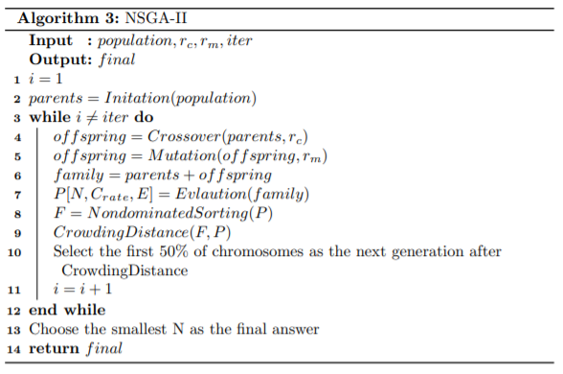 The process of proposed NSGA-II is showed in Algorithm 3. In the input parameters, *population* is the amount of initial chromosome population. *iter* is an integer for stopping criteria. $r_{c}$ and $r_{c}$ are the rate of crossover and mutation respectively. *final* is the output solution which determines the placement of charging stations.